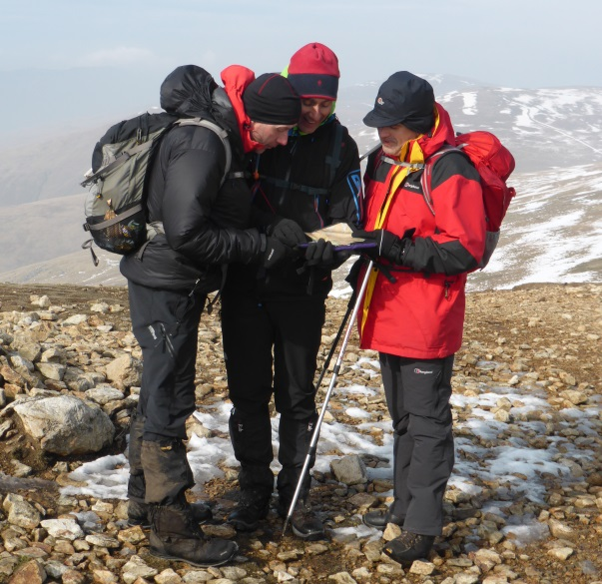

antondotreks.com
BOOKING FORM

Please complete one booking form per person

Thank you for choosing antondotreks.com for your navigation course or outdoor adventure. I am really looking forward to meeting you and I am sure we will have an enjoyable and memorable time in the Great Outdoors!

BOOKING DETAILS

Course/Activity Location Dates

YOUR DETAILS

Your name

Your phone number Your email address Your postal address

Emergency contact
(name and ‘phone number)

PAYMENT Cheque attached payable to JA Greenwood

Paid online (see invoice)

antondotreks provides the walking activities only.
All participants must provide their own travel, food, accommodation and walking boots.
WHAT TO WEAR & BRING WITH YOU

What to wear
It is important to wear a 'layering system' of clothing as follows:
• Base layer - long-sleeved T-shirt
• Mid layer – fleece
• Outer shell - waterproof/breathable coat and over-trousers
• Walking boots. These must be waterproof with good ankle support and sturdy soles
• plus walking trousers

Wear clothing that is made from synthetic fibres, which are quick drying and help 'wick' moisture away from your skin. Do NOT wear cotton (especially jeans) as cotton soaks up moisture.

What to bring
• Sunhat, sunscreen and sunglasses (spring to early autumn)
• Warm hat
• Waterproof gloves
• Water bottle (at least 1 litre)
• Flask for hot drink
• Spare fleece
• Packed lunch
• High energy snack food (dried fruit, nuts, muesli bars, chocolate bars etc)
• Medications (if applicable)
• Camera, binoculars etc
• Rucksack (to carry all of this in!)

Please see your Course Overview for more details about your chosen activity
PARTICIPANT INFORMATION
We need to know a little about you.

Medical conditions:
Please list any pre-existing medical condition that may affect your participation in this activity. Please ensure that you bring any medication that you may need with you on your activity. If you suffer from a pre-existing medical condition that may make it unsafe for you to take part in this activity, then it may be necessary to seek advice from your GP. All information will be treated in confidence.

Name Age

What is your level of fitness? What regular exercise do you currently do?

□ Physical activity 0 or 1 day per week
□ Physical activity 2 - 4 days per week
□ Physical activity 5 or more days per week
NB: ‘physical activity’ means a minimum of 30 minutes of moderate exercise, such as brisk walking, swimming, jogging, cycling etc

Your hill-walking experience Do you need a Map and/or compass?
(I can provide a loan compass, let me know)

Medical conditions, allergies or special requirements
Please list any pre-existing medical conditions, allergies or special requirements that may affect your participation in this
activity.

None

By completing and returning this Booking Form you confirm that you have read through, understood and accepted the Terms & Conditions, and that you are fully aware of the type of activity you have chosen to take part in.

PLEASE E-MAIL TO:
Tony.greenwood@antondotreks.com
Please return as soon as possible. Places subject to availability.
BOOKING TERMS & CONDITIONS IMPORTANT: please read carefully
• Part of the attraction of valley, hill and mountain walking is the challenge of tackling different terrains, landscapes and weather conditions. Every effort is made to minimize potential hazards; however, the very nature of hill and mountain walking involves a certain level of unavoidable risk of accident and/or injury. By taking part in this activity, you are aware of and accept these risks.
• All walks will involve a varying degree of rough terrain, muddy/rocky/wet ground, remote open country, high ground, moorland, mountainous terrain, stiles, stream crossings, roads and lanes, farms and livestock as well as a number of ascents/descents, some of which may be steep. We may also encounter adverse weather conditions whilst on the walk.
• Walking and outdoor activities can be strenuous. Never underestimate the strenuous nature of walking particularly when this is combined with high ground and the elements.
• No previous hill-walking experience is required and walks are ‘pitched’ according to the experience and average fitness levels of the group. However, a reasonable level of fitness is required as the natural environment can be demanding at times.
• All participants must provide suitable outdoor footwear, preferably walking boots, with sturdy cleated soles and ankle support.
• Tony Greenwood or his freelance Mountain Leaders (Walk Leaders) accept no responsibility for personal accidents or injury or for loss or damage to personal effects unless caused by their negligence as Walk Leaders. We strongly recommend you have adequate personal insurance cover for accident or injury, as well as travel insurance in case of cancellation.
• All participants must take heed of any information, guidance or hazard warnings given by the Walk Leader during the pre-walk briefing or whilst on the walk.
• The Walk Leader reserves the right to refuse to take a participant whom they consider will be unable to complete the planned activity or is wearing unsuitable clothing.
• Accommodation, Food & Travel - You must book and pay for any accommodation, food and/or travel (the 'service provided')
directly yourself. The contract for the service provided is between the person making the booking and the service provider.
• Payments - full payment is required prior to the outdoor course or activity (the ‘event’) to secure your booking.
• Transfer of Booking – You may transfer your booking to another advertised date (subject to availability) subject to the payment of the following transfer fees:
Ø Within 7 days from the date you paid for your booking (‘date of booking’) – free transfer
Ø After 7 days from date of booking & over 14 days before the event – additional payment of 25% of the cost of the event.
Ø 7 – 14 days before the event – additional payment of 50% of the cost of the event.
Ø Within 7 days of the event – additional payment of 75% of the cost of the event.
These transfer fees are payable at the time of transfer (plus any price difference). All transfers must be made prior to the event.
• Cancellations: You may cancel your booking any time within 7 days from the date you paid for your booking ('date of booking'), and we will refund the cost of your booking in full. All cancellations must be confirmed in writing by email, text or post. Cancellations after 7 days from the date of booking will be subject to the following cancellation charges (which will be deducted from your refund):
• Over 28 days before the event – cancellation charge of 25% of the cost of the event.
• 14 – 28 days before the event – cancellation charge of 50% of the cost of the event.
• 7 – 14 days before the event – cancellation charge of 75% of the cost of the event.
• 1 – 7 days before the event or non attendance – cancellation charge of 100% of the cost of the event.
• The event may be cancelled by the Walk Leader within 48 hours of the event due to adverse weather conditions or forecast. If
the event is cancelled by the Walk Leader then the event will either be rescheduled for another date, your booking transferred to
another advertised date or a credit note issued to be redeemed within 12 months against any antondotreks event. The decision to cancel the event lies solely with the Walk Leader. In the event of cancellation by the Walk Leader, then antondotreks liability is limited to the cost of your chosen activity only. We recommend you have adequate travel insurance in case of cancellation.
• The pre-planned routes may be subject to change whilst on the walk due to adverse weather conditions, pace of the group, fitness and ability levels, accidents or injuries etc. In extreme circumstances the walk may be terminated. Once the walk has commenced then any such changes to the pre-planned walk are deemed to be part of the event. The decision to change or terminate the walk lies solely with the Walk Leader.
•


Tony Greenwood is a qualified Mountain Leader, and holds a current Outdoors First Aid certificate as well as Public and Civil Liability Insurance.

Antondotreks.com
Tony Greenwood, 69 Smithills Croft Road, Bolton, BL1 6TX

(M) 07885 241092 (E) tony.greenwood@antondotreks.com

